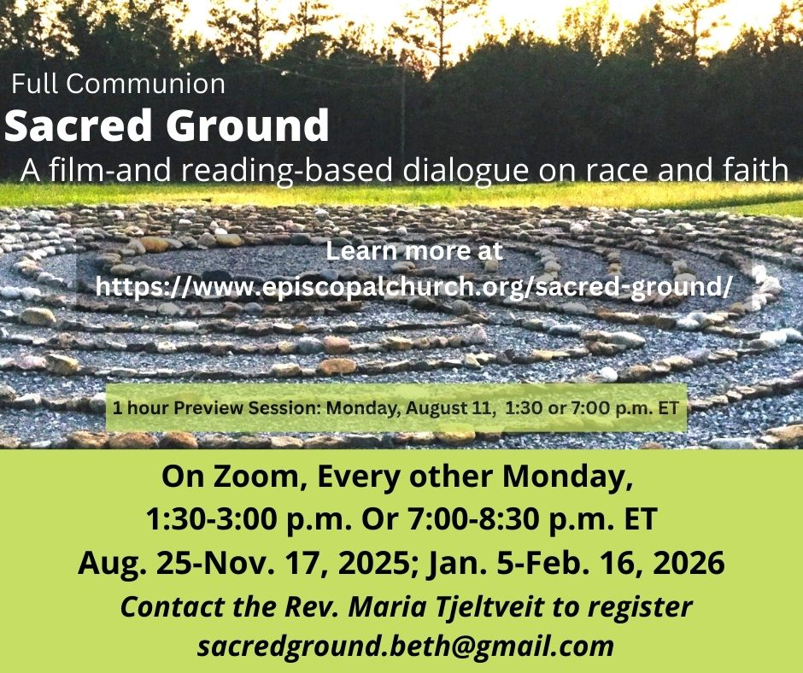
SESSIONS
August 25 1. Stepping onto Sacred Ground (2-hour session)
September 8 2. The Roots of Whiteness, and Deeper Roots
September 22 3. Whose Land? Exploring Indigenous History
October 6 4. Transatlantic Slave Trade and Slavery: Exploring Black History
October 20 5. Whose Land? More Layers: Exploring Latino History
November 3 6. Americans, Not Foreigners: Exploring Asian/Pacific American History
November 17 7. Selective Access to the Melting Pot and the American Dream: 1830s-1960s
BREAK!

January 5 8. Divisions in Present-Day White America
January 19 9. Legacies: Racism’s Long Life
February 2 10. Grief, Reckoning and Repentance (2-hour session)
February 16 11. Walk On: The Journey After Sacred Ground (2-hour Session)

